SCENT WEBSITE STRUCTURE
1. HOME PAGE
- Menu and header bar same as Chanel
Hero Image – to be selected
Hero Image content “ SCENT – where haircut is just an excuse…”
CTA – BOOK YOUR EXPERIENCE

- Service Section ( REDIFINE YOUR LOOK)
- HAIR
- Haircut
- Colour
- Treatments
- Hairspa
- SKIN
- Facials
- Waxing
- Threading
- NAIL
- Manicure & pedicure

- Body therapy

- LASHES

- MAKEUP

- MEMBERSHIPS

- The essense of SCENT ( our story)
BRAND OVERVIEW – Experience || No. Of Salons || People Served
- Video Section

- TRUSTED BY THE BEST (Brands/Partners which we want to show)
- Schwarzkopf
- Ola plex
- Beauty garage
- Casmara
- Jansen
- Jeannot
- Skyndor
- Morrocan
- Cadiveu
- Biosoft
- Pedi calm

- Store Locator

- WHY Scent – Care icons
- BLOGS
- Testimonials
- Footer

(Small Writeup about all with Read More button) – Sends them to service page
Menu Drop down also available for them to send directly to specific service page
Individual Service page :
1. HAIR CARE
- HERO IMAGE
- CONTENT ABOUT HAIR CARE
- SUB CATEGORIES –> (TAKE FROM MENU)
CUSTOMER EXPERIENCE – youtube video links
Store Locator
WHY SCENT
Footer

( DO FOR ALL THE SERVICES)

3. Salon Member Ship
Platinum
Sapphire
Diamond
Gold
Ruby
Silver
** After clicking it has flip animation – CTA - BOOK NOW
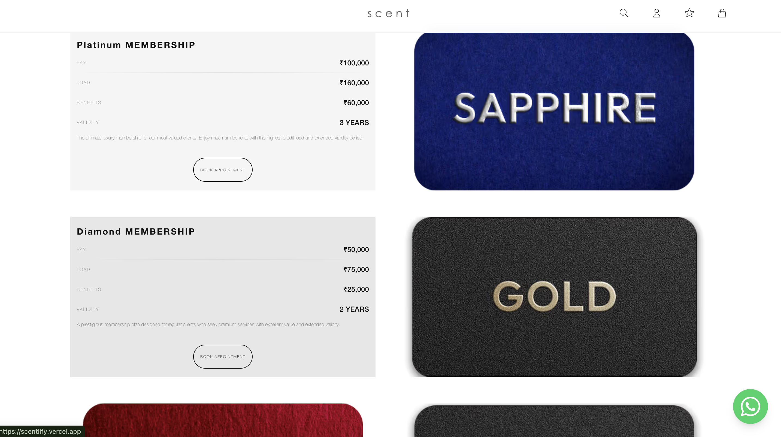
4. FRANCHISE
Hero section with UNLOCK THE OPPORTUNITY tagline
-Below HERO SECTION content -
If you're dreaming of owning a business that combines creativity, style, and a thriving market, look no further than a Salon Franchise in Bangalore with SCENT. As one of the most cosmopolitan cities in India, Bangalore is a hub of fashion and beauty, making it the ideal location to start your journey in the lucrative salon industry. At SCENT, we offer a unique opportunity to tap into this ever-growing demand by partnering with a renowned brand that is synonymous with quality, innovation, and customer satisfaction.
Why Choose a Salon Franchise in Bangalore?
❀
Choosing a Salon Franchise in Bangalore with SCENT provides you with a proven business model, industry expertise, and a strong brand reputation. The beauty and wellness industry in Bangalore is booming, with a steady influx of young professionals, expats, and fashion-conscious consumers who seek the best in beauty treatments. A salon franchise with SCENT allows you to cater to this dynamic market with confidence, offering premium services that are trusted by thousands.
--GET IN TOUCH Box with enquiry form and contact information on right--
The SCENT Advantage for Your Salon Franchise in Bangalore
❀
When you decide to open a Salon Franchise in Bangalore with SCENT, you're not just opening a salon; you're becoming part of a brand that is synonymous with luxury, style, and cutting-edge beauty trends. Our franchise model comes with numerous benefits:
1. Brand Recognition
SCENT is already a well-known name in the beauty industry, recognized for its exceptional quality and customer service. Your salon franchise in Bangalore will benefit from this established reputation, attracting clients from day one.
2. Comprehensive Training
We provide extensive training programs for you and your staff, ensuring that your Salon Franchise in Bangalore operates smoothly and meets our high standards. From hair styling and skincare techniques to customer service and management, we cover it all.
3. Marketing and Promotional Support
Our marketing team will help you create buzz around your new Salon Franchise in Bangalore through strategic campaigns, social media promotions, and local events. This ensures a steady stream of customers eager to experience SCENT's renowned services.
4. Proven Business Model
With years of experience in the industry, we have developed a successful business model that reduces risk and increases profitability. When you choose a Salon Franchise in Bangalore with SCENT, you're leveraging a proven formula that works.
5. Exclusive Access to Premium Products
SCENT franchises have access to exclusive, high-quality beauty products that are not available to other salons. This unique offering sets your Salon Franchise in Bangalore apart, ensuring customer loyalty and repeat business.
Steps to Open Your Salon Franchise in Bangalore with SCENT
Opening a Salon Franchise in Bangalore with SCENT is a straightforward process designed to get you up and running quickly:

- Initial Consultation
Our team will discuss your goals, budget, and location preferences to determine the best strategy for your salon franchise.

- Franchise Agreement
Once the terms are agreed upon, we will sign a franchise agreement that outlines your responsibilities, the support you will receive, and other key details.

- Site Selection and Setup
Our experts will help you choose the ideal location for your Salon Franchise in Bangalore, ensuring maximum visibility and foot traffic. We will also assist with the interior design, layout, and equipment setup to create a space that reflects the SCENT brand.

- Training and Staffing
Comprehensive training will be provided for you and your staff, covering all aspects of salon management, customer service, and beauty treatments.

- Grand Opening
We will support you with a grand opening event to create buzz and attract your first clients. From there, you will have ongoing support from our marketing, operations, and training teams.
Success Stories from Our Salon Franchise in Bangalore
❀
Many entrepreneurs have found tremendous success by opening a Salon Franchise in Bangalore with SCENT. Our franchisees come from diverse backgrounds – from beauty professionals to corporate executives – all united by their passion for the beauty industry and commitment to excellence. With SCENT's guidance, they have transformed their dreams into reality, enjoying financial success and personal fulfillment.
What Makes SCENT the Best Choice for Your Salon Franchise in Bangalore?
Bangalore is a vibrant city, full of opportunities for growth and innovation in the beauty sector. By partnering with SCENT, you are choosing a brand that understands the nuances of this market and has a track record of success. Our Salon Franchise in Bangalore is tailored to suit the unique needs of Bangalore's clientele, providing premium services that include hair styling, skincare, nail art, spa treatments, and more.

At SCENT, we believe in empowering our franchisees. That's why we provide you with the tools, training, and support necessary to make your Salon Franchise in Bangalore a success. From the moment you sign the franchise agreement, you become a valued partner in our network, benefiting from our reputation, resources, and expertise.
A Profitable Business Opportunity Awaits
The demand for high-quality beauty services in Bangalore continues to grow, making now the perfect time to invest in a Salon Franchise in Bangalore. With SCENT's support, you can enter this booming market with confidence, knowing you have a trusted brand backing you every step of the way.
How to Get Started
If you're ready to take the first step toward owning a Salon Franchise in Bangalore, contact us today! Our team will provide you with all the information you need to make an informed decision and guide you through the process of becoming a SCENT franchisee. Don't miss this opportunity to be part of a brand that is redefining the beauty industry.

Owning a Salon Franchise in Bangalore with SCENT is more than just a business opportunity – it's a chance to be part of a growing community of beauty enthusiasts, entrepreneurs, and professionals who are passionate about delivering exceptional services. With our proven business model, strong brand reputation, and ongoing support, you can turn your dream of owning a salon into a profitable reality. Join us and experience the SCENT difference today!
CTA of Contact US

FOOTER
** A small Write up about services and Categories definition will help us structure better**

